CONSCIOUS CONVERSATIONS
Presented by Lyndy Lubbers, Longmont American Association of University Women
October 10 and 17, 2017

Four Types of Conversations
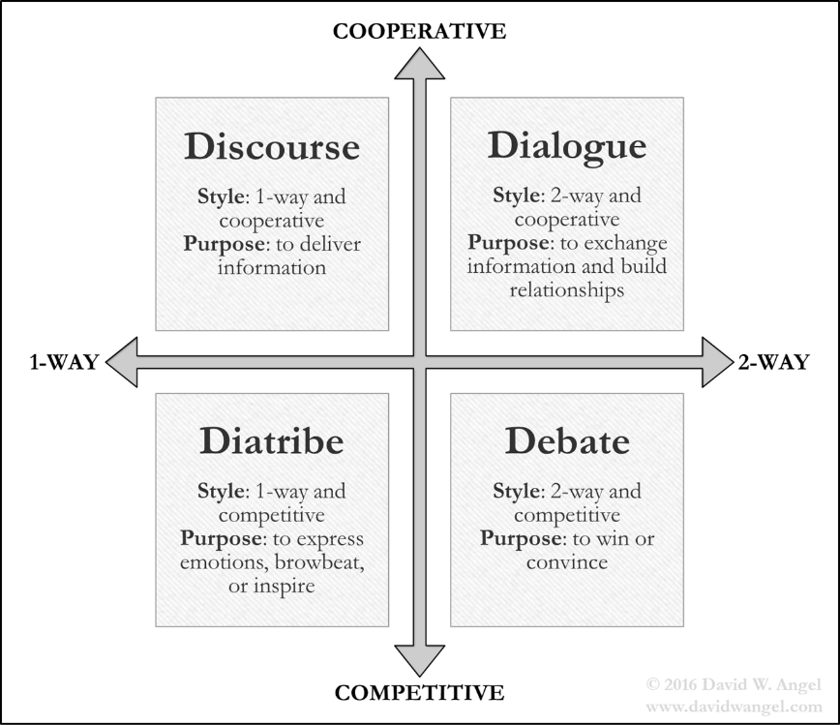
TED Talk by Celeste Headley at https://www.ted.com/talks/celeste_headlee_10_ways_to_have_a_better_conversation
Books by Daniel Goleman
Emotional Intelligence and Social Intelligence

This is the area we are primarily focusing on in these 2 sessions

Trust
#1 Organic – will do the right thing; will be taken care of
#2 Contractual – delineated agreements
#3 Relational – this is the kind that matters; most powerful; “do what I say I’m going to do”

Rapport
• Relationship “magic”; can be established instantaneously”
• Elements of rapport – posture, gesture, tonality, language, and breathing

Listening Set-asides – things we should avoid if trying to establish rapport
• Autobiographical – associating someone else’s experience to your own; “kindergarten”, egocentric listening
• Inquisitive – “Soap opera” listening; wanting to know all of the details to satisfy your curiosity
• Solution – acting as a “problem solver” because you have the experience

Paraphrasing
• The premier coaching tool; allows increases in rapport and relationship; it is the Productive way of listening
• Skilled paraphrasing treats responses as gifts
• Should reflect both content and emotion
• Good starts when paraphrasing - “You’re suggesting …”; “You’re proposing …”; “Your hunch is that …”; “So you’re wondering about …”

Principles of Paraphrasing
• Attend fully (this is why we learn to build rapport first)
• Listen with the intent to understand
• Capture essence of message (paraphrase, not parrot phrase)
• Make paraphrase shorter than original message
• Paraphrase before asking a question so it doesn’t feel like an interrogation
• Be allocentric by using pronoun “you” instead of “I”; don’t be egocentric
Paraphrasing sends the message that I truly care about what you are saying; your opinion is important to me.

Pausing
• Signals we are listening and thinking
• Changes the pace of the conversation
• Clearest way to say, “I value your opinion”

Wait Time and Eye Movements
• Visual Recall and Visual Construct – have a clear vision of the experience and building something in our mind
• Auditory Recall and Auditory Construct – remembering the words and hearing the conversation in our mind
• Kinesthetic / Emotive – Give time for this, don’t rush, especially in an emotional situation
• Internal Dialogue – They are having a conversation with themselves; may mean they don’t have a lot to say

4 Characteristics of a Good Question
- Invitational – use an approachable voice
- Plural Forms – “What are your reasons …”, “What possibilities do you see?”; see more than one option
- Tentative Language – “What are your thoughts …”; avoid “why” questions to avoid interrogating
- Positive Presuppositions – “What options seem most promising …”; assume we all want to same things such as safety, health, etc.

